Exercise 2

Kendrick Kwong

**Script:**

randomNum.h:

randomNum.c

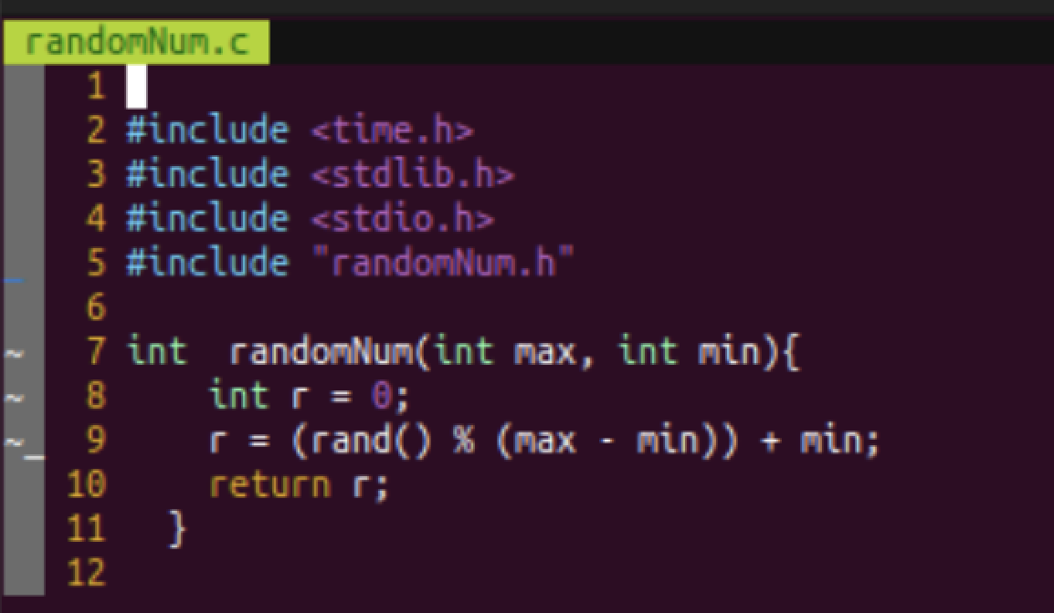

Main.c:

**Preprocessor:**

To invoke GCC and only carry out the preprocessor command:

*gcc -E in.c -o in.i*

copy the output of the preprocessor to another .c file

The difference between my .c files and what they look like after the preprocessor has done its thing is that it will generation an object file (i.e_randomNum.o , main.o)

**Compilation:**

Command to compile:

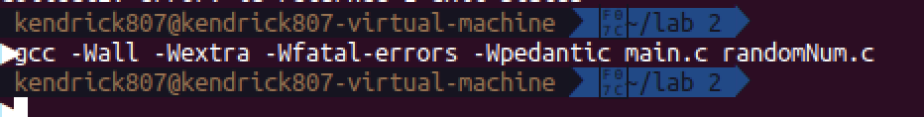

**-Wall**

Enables all compiler's warning messages. This option should always be used, in order to generate better code.

**-Wextra**

Warn if a comparison is always true or always false due to the limited range of the data type, but do not warn for constant expressions. For example, warn if an unsigned variable is compared against zero with '<' or '>='. This warning is also enabled by

**-Wfatal-errors**

This option causes the compiler to abort compilation on the first error occurred rather than trying to keep going and printing further error messages.

**-Wpedantic**

GCC compilers always try to compile your program if this is at all possible. However, in some cases, the C and C++ standards specify that certain extensions are forbidden. Conforming compilers such as GCC or g++ must issue a diagnostic when these extensions are encountered.

the GCC compiler’s -pedantic option causes GCC to issue warnings in such cases.

When the command -Ofast is used instead of -O, the compile time increased but the execution time decreased.

**Linking:**

Command:

**Execution and debugging:**

Command:

